**Old Establishment Indices**

Created by Fisher Ankney, [fisherankney@gmail.com](mailto:fisherankney@gmail.com), February 14, 2017

Updated February 21, 2017

***Description –***

To better understand cottonwood growth at each of the four Bijou Creek Sites I comparing chronologies and indices within four older group of trees with estimated establishment dates ranging between 1918 and 1941.

***Sources* –**

The old establishment indices study uses tree ring RCS chronologies and indices that are calculated in the folder Bijou Creek / analysis / standardized RCS indices. These calculations are the basis for any study folder that has the prefix “indices –“. Selecting the participating samples in this study was simply a matter of finding a common cohort of older-aged trees between the four study sites. A minimum of five tree establishments (10 cores) had to be present within a span of 25 years. The youngest possible cohort that met these requirements spans from 1918 – 1941, and are thus included here. For more information on the exact cores used, see the source below.

Old_establish_source.xls

***Scripts –***

*Old_establish_chronologies_script.R*

*Old_establish_indices_script.R*

*Old_establish_downstream_indices_script.R*

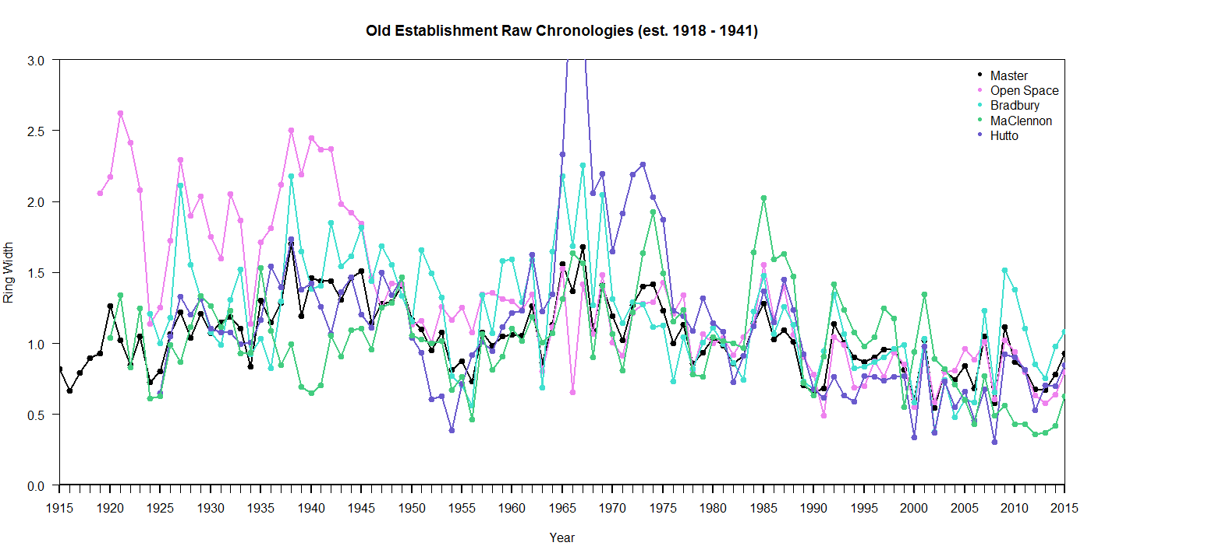***Results –***

